**Laboratory 5**

Andreas Alexa & Apostu Sergiu

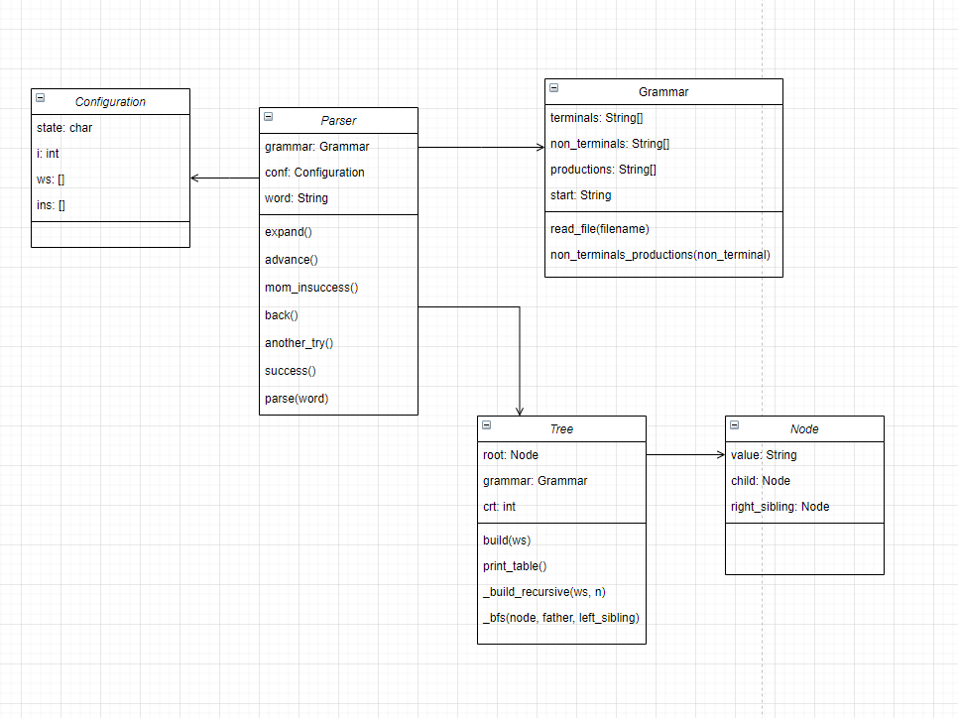<https://github.com/AlexaAndreas99/FLCD/tree/master/lab5>